E-COMMERCE CUSTOMER INTELLIGENCE & RECOMMENDATION SYSTEM
Project Report
Submitted By:Gawate Motiram Babu
Roll No.: 54
Class: BCA – Semester V
College:SSBES ITM College Nanded
GitHub: Ecommerce--Customer-Intelligence-recomnedtation/Product_Recommendation_System.ipynb at main · gawatemotiram15-del/Ecommerce--Customer-Intelligence-recomnedtation

Under the Guidance of:
Mr. K. Nikhil Sir
Organization:
AiSyntelligence LLP, Pune
Domain:
Artificial Intelligence & Machine Learning
Academic Year: 2026

1. INTRODUCTION
Product Recommendation System is an important application of Machine Learning and Data Analysis in e-commerce. It helps businesses understand customer purchasing behaviour and recommend products based on the products that are frequently purchased.
This project uses the Olist e-commerce dataset, which contains information about orders, products and order items. The main objective of this project is to analyse product purchase patterns and identify the most frequently purchased products.
In this project, the order items dataset is merged with the product dataset using product_id. The purchase count of each product is then calculated to identify the top recommended products. A category-wise recommendation function is also developed to recommend the top products from a selected product category.
The final results are displayed using tables and a bar chart, which makes it easier to understand the most frequently purchased and recommended products.

2. PROBLEM STATEMENT
E-commerce platforms contain a large amount of product and transaction data. It can be difficult to manually identify which products are frequently purchased by customers.
Therefore, there is a need for a system that can analyse product purchase data and identify popular products. The problem addressed in this project is to develop a simple Product Recommendation System that recommends products based on their purchase frequency and product category.

3. OBJECTIVES
To analyse e-commerce product purchasing data.
To combine order-item data with product information.
To calculate the purchase count of products.
To identify the top frequently purchased products.
To recommend products based on product category.
To visualize recommended products using a bar chart.

4. DATASET DESCRIPTION
The project uses the Brazilian E-Commerce Public Dataset by Olist. The Product Recommendation System uses three datasets:
olist_orders_dataset.csv – contains order information.
olist_products_dataset.csv – contains product information and product categories.
olist_order_items_dataset.csv – contains information about products purchased in orders.
The order items and products datasets are merged using the product_id column. This combined data is used to calculate product purchase frequency and generate product recommendations.

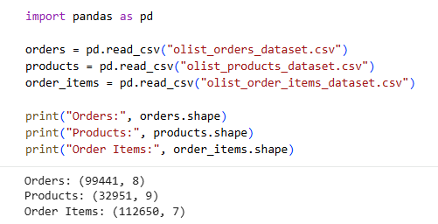

5. DATA PREPROCESSING
The datasets required for the Product Recommendation System are loaded using Pandas. The order-item and product datasets are examined before building the recommendation system.
The order items dataset contains product purchase information, while the products dataset contains product details and category information.
The two datasets are merged using the common product_id column. This combines purchase information with product category information and creates a dataset suitable for recommendation analysis.
After merging the datasets, the products are grouped by product_id and product_category_name. The number of records for each product is counted to obtain the purchase count.
The products are then sorted in descending order according to their purchase count. This allows the system to identify the most frequently purchased products and use them for recommendation.

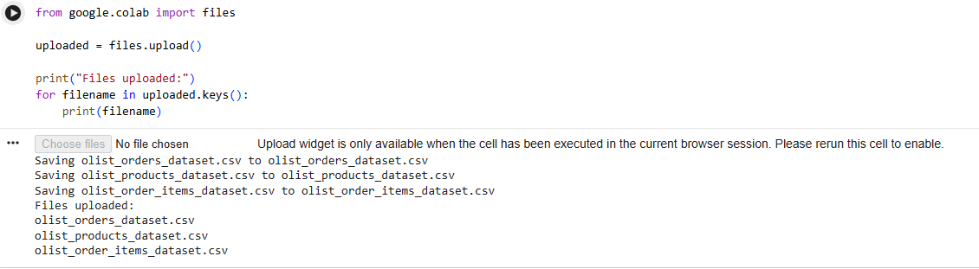
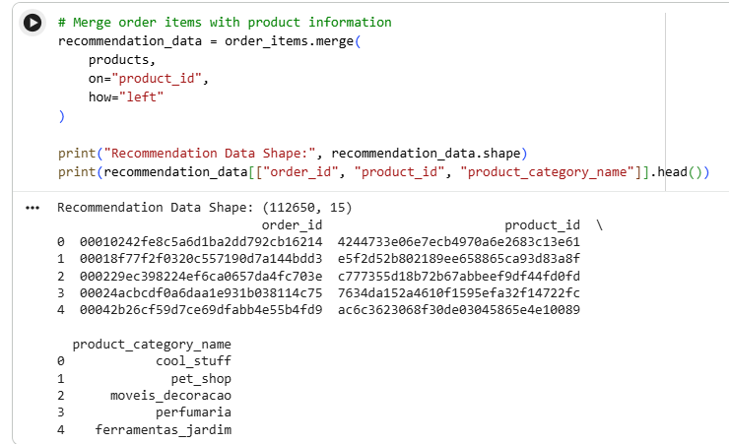

6. PRODUCT RECOMMENDATION METHOD
The recommendation system uses a purchase-frequency-based approach to identify popular products.
First, the user selects a product category. The system filters the data according to the selected category. It then counts how many times each product was purchased.
The products are sorted according to their purchase count in descending order. The system then selects the Top 5 products with the highest purchase frequency.
A recommendation function is used to generate category-wise recommendations. For example, the selected category ferramentas_jardim is used to generate the recommendations shown in the output.
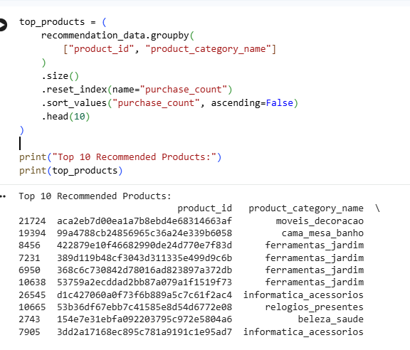

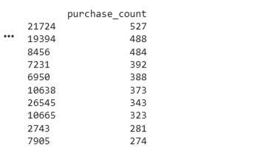

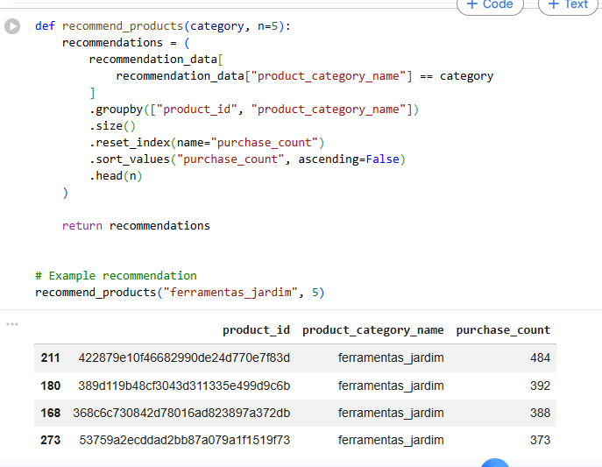

7. IMPLEMENTATION
The Product Recommendation System is implemented using Python and the Pandas library for data processing.
The implementation performs the following steps:
Load the required CSV datasets.
Merge the order items and products datasets using product_id.
Group the data by product_id and product_category_name.
Calculate the purchase count for each product.
Sort the products by purchase count in descending order.
Create the recommend_products() function.
Select a product category and generate the Top 5 recommendations.
Display the recommendations using a bar chart.
This implementation produces category-based product recommendations using the purchase frequency available in the dataset.

8. RESULTS AND OUTPUT
The Product Recommendation System successfully generates product recommendations based on purchase frequency.
For a selected product category, the system identifies the products with the highest number of purchases and displays the Top 5 recommended products.
The recommendations are also represented using a bar chart. The chart displays:
X-axis: Product ID
Y-axis: Purchase Count
For the selected category ferramentas_jardim, the system successfully generates the recommended products and their purchase counts.
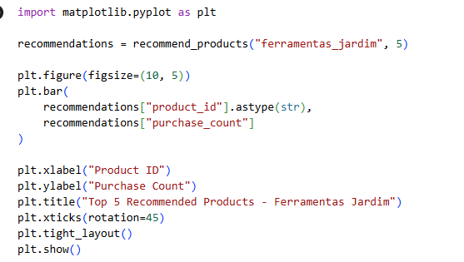
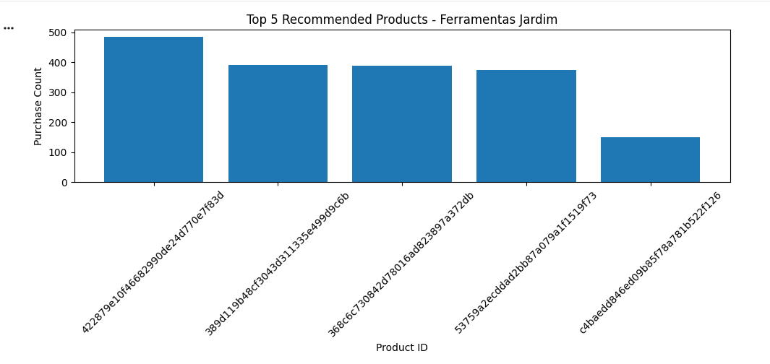

9. ADVANTAGES
Helps identify frequently purchased products.
Provides product recommendations based on actual purchase frequency.
Supports category-wise product recommendations.
Simple and easy-to-understand recommendation approach.
Helps visualize popular products using a bar chart.
Can help e-commerce businesses understand product demand.

10. LIMITATIONS
Recommendations are based mainly on purchase frequency.
The system does not use individual customer preferences.
New products with fewer purchases may receive less recommendation.
The recommendation quality depends on the available purchase data.
It does not consider product reviews or customer ratings.

11. FUTURE SCOPE
The recommendation system can be improved by considering individual customer preferences.
Product ratings and reviews can be included in future recommendations.
Customer purchase history can be used to provide personalized recommendations.
More advanced recommendation algorithms can be added in the future.
The system can be integrated into an e-commerce dashboard or application.

12. CONCLUSION
The Product Recommendation System successfully analyses e-commerce purchase data and identifies frequently purchased products. The order-item and product datasets are combined using product_id, and the purchase frequency of products is calculated.
Based on the purchase count, the system generates Top 5 product recommendations for a selected category. The recommendations are also displayed using a bar chart for easy understanding.
The project demonstrates how e-commerce purchase data can be used to identify popular products and generate simple, category-based product recommendations.

END OF PROJECT REPORT

